Radio Drama Research

Grimms Fairy Tales

What is a Grimms fairy tale? Who wrote them? When?
The Grimms' Fairy Tales, originally known as the Children's and Household Tale, is a collection of fairy tales by the Grimm brothers or "Brothers Grimm", Jakob and Wilhelm, first published on 20 December 1812. The first edition contained 86 stories, and by the seventh edition in 1857, had 211 unique fairy tales.

A Grimms fairy tale usually has a moral at the end of the story and it tends to be gruesome and not a happy ever after.

In our group for this project we chose to do the fairytale “Rapunzel” We Chose to do this because we had good ideas for adaptations and we also liked this story as we all knew it from when we were younger and we all loved the film Rapunzel.

Rapunzel was written in 1812 and is about how Rapunzel lives in a tower with controlling Mother Gothel. The charming fugitive, Flynn Rider, helps her escape and explore the kingdom. While Rapunzel falls in love with Flynn, despite learning his real name is Eugene, she also learns she is actually a princess.

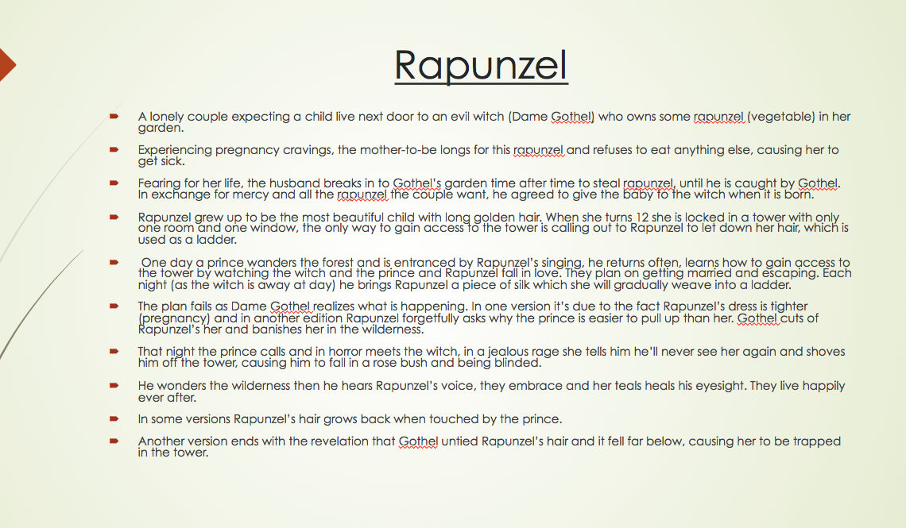

Radio Drama

What is a radio drama?
Radio drama is a dramatized, purely acoustic performance. With no visual component, radio drama depends on dialogue, music and sound effects to help the listener imagine the characters and story: "It is auditory in the physical dimension but equally powerful as a visual force in the psychological dimension.

Radio dramas first became popular in 1920 when they were invented. The first radio drama started in America. One of the first radio dramas written in UK was Danger by Richard Hughes BBC broadcast it broadcast in January 15 1924. ... In 1938 Orson Welles's famous war of the worlds was broadcast.

The Top 10 Greatest Radio Dramas
- 3) Johnny Got His Gun (1940)
- 4) War of the Worlds (1938)
- 5) Ruby 4 (1994)
- 6) The Knox Riots (1926)
- 7) Escape: “Three Skeleton Key” (1950)
- 8) Yours Truly, Johnny Dollar: The Todd Matter (1956)
- 9) The Origin of Superman, Retold (1945)
- 10) Brave New World (1956)

How to create a radio drama
•
Create a visual picture. Writing for radio requires you to paint a picture in the audience's mind
• Use the narrator device
• Create action through dialogue
• Make the most of sound effects
• Use Mixer effects
• Include music. characters.
• Be precise and clear with your language.

Equipment
- Good actors with good voices
- Good and clear script
- Audio equipment, Boom mic, Zoom , SD card, headphones
- Quiet place to film, sound proof room

List of resources we need for Foley
- Cabbage
- Door
- Clock Tower
- Wood
- Actor
- Stones
- Camera noise
- Wedding bells
- Hitting a wal or desk,
- Roar or scream
- Wig, cutting with scissors

Target Audience
Our target is teenagers aged around 13-25 year olds. We chose a story that most of our target audience will be famililar with as they are more likely to be interested in hearing our adaption. Our story also includes themes of parenthood and conflict something our target audience may relate and appeal to . Also they most likely grew up with this fairytale in their genre.

