Interactive Media

What is interactive media?
A social media campaign is a coordinated marketing effort to reinforce or assist with a business goal using one or more social media platforms. Campaigns differ from everyday social media efforts because of their increased focus, targeting and measurability.

I use instagram to show and promote the context I make within my media college course. I use many different social media platforms such as YouTube, Facebook, Twitter etc. but I prefer to use instagram as I believe currently that is the platform that is getting the most attention and views and best to follow people in the public eye.

I use YouTube to upload the videos I create and then use instagram to follow up these videos by posting clips from them and linking my YouTube channel; therefore I can promote all my other social media links through instagram getting my followers attention. Also instagram is good for getting a larger following as word of mouth goes around and a large following on instagarm means more chance of being in the public eye.

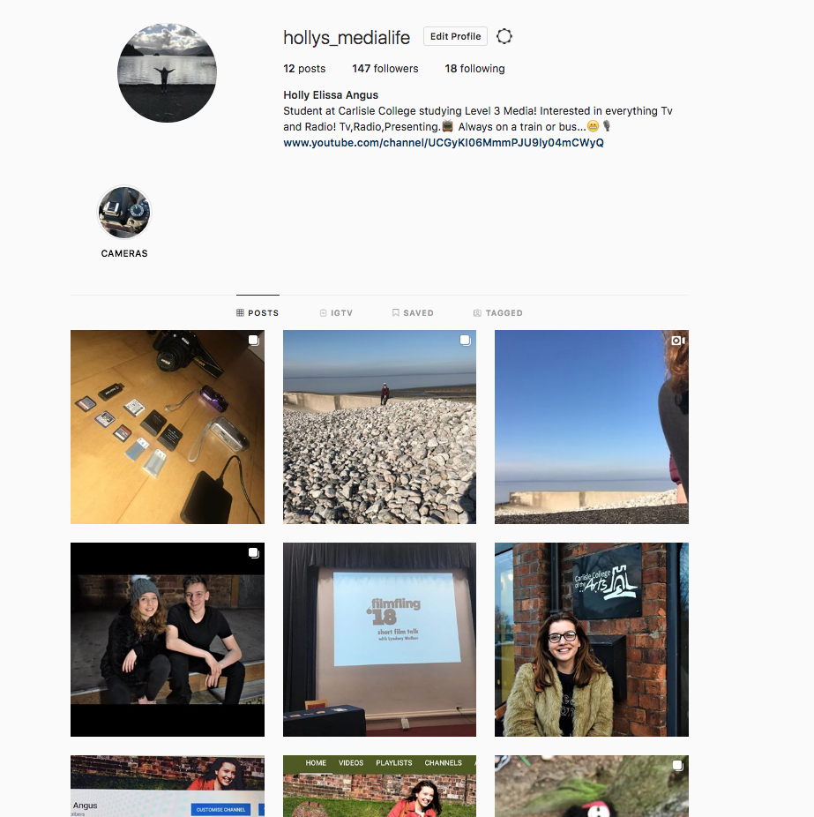

So far on my instagram I have had a positive response. I have gained 147 followers and have posted many photos related to my college work.

So I took to social media to see what platform people mostly used to find out the latest news and follow their favourite celebrity’s and friends.

I used my instagram page to ask my followers what social media platform they use the most to get a general understanding of what social media platforms are most popular. I got a lot of responses and the most common was Snapchat. I feel this is because for my genre of age 16-19, snapchat is a quick and easy way to talk to friends and post about what you are getting up too. However I feel instagarm is the best platform for promoting business pages. As you can post hash tags, and links and other small business trying to get noticed.
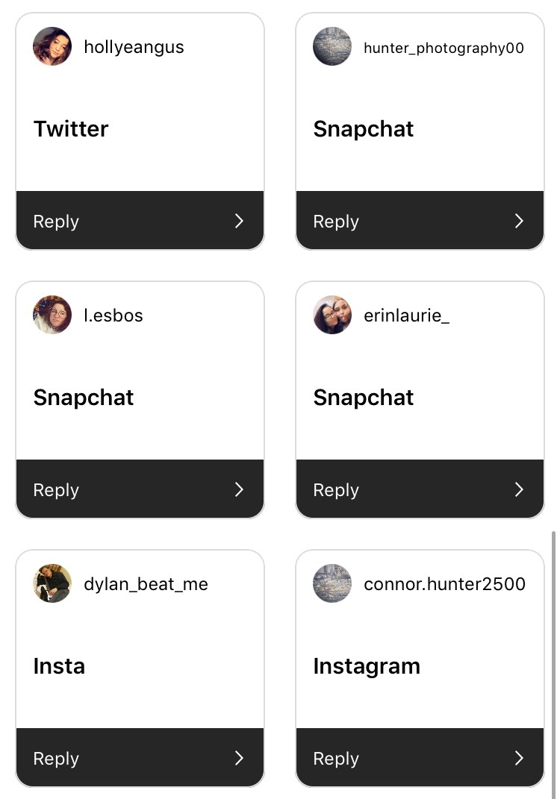
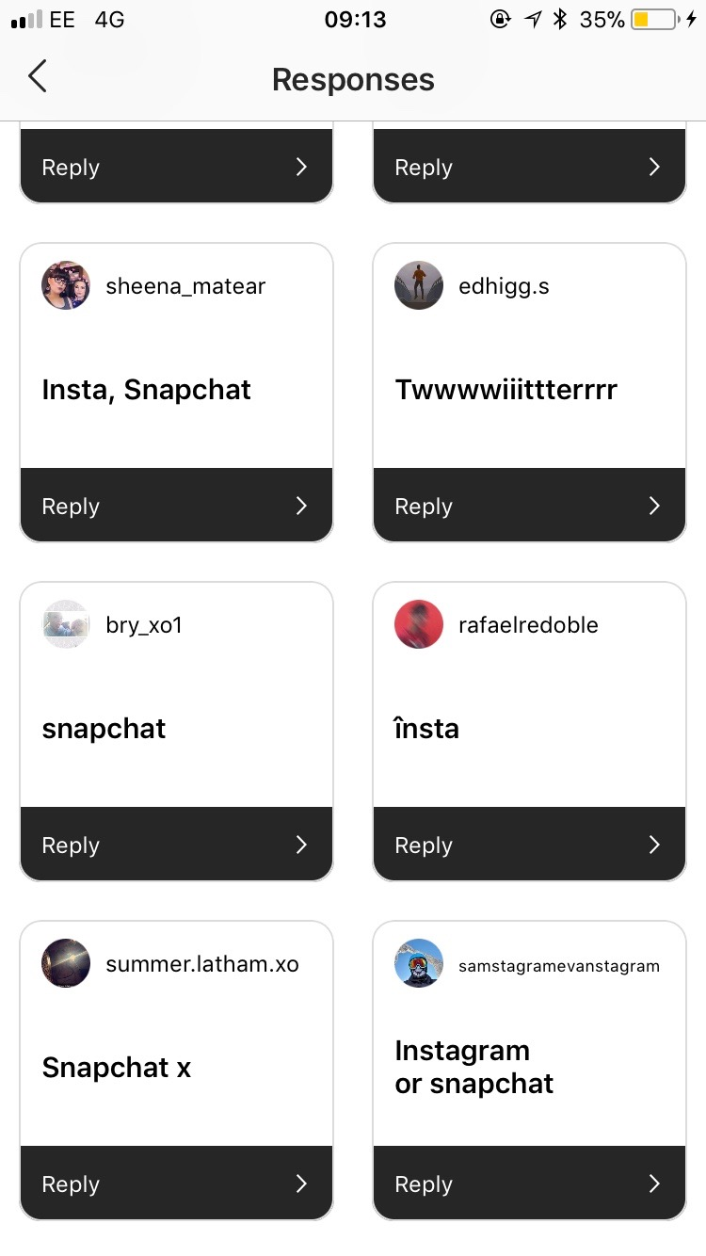
Research into how social media platforms help businesses.

MARKETING-Businesses are constantly finding new ways to implement their marketing strategies through social media. Prior to the development of social media platforms, businesses relied on fliers sent through the mail, television commercials and word of mouth. While these marketing tactics are still useful, businesses can now use social media to instantly inform consumers about sales, the arrival of new products and exclusive promotions. Consumers can connect with their favourite retailers online to stay informed about new developments.

COMMUNICATION- Social media also affects the way many retail businesses communicate with their customers. ... Customers may send private messages to the business, or they may post information publicly. Customers use social media to provide both positive and negative feedback about products or customer service.

